**ONLINE PALENGKE**

* **Logo**

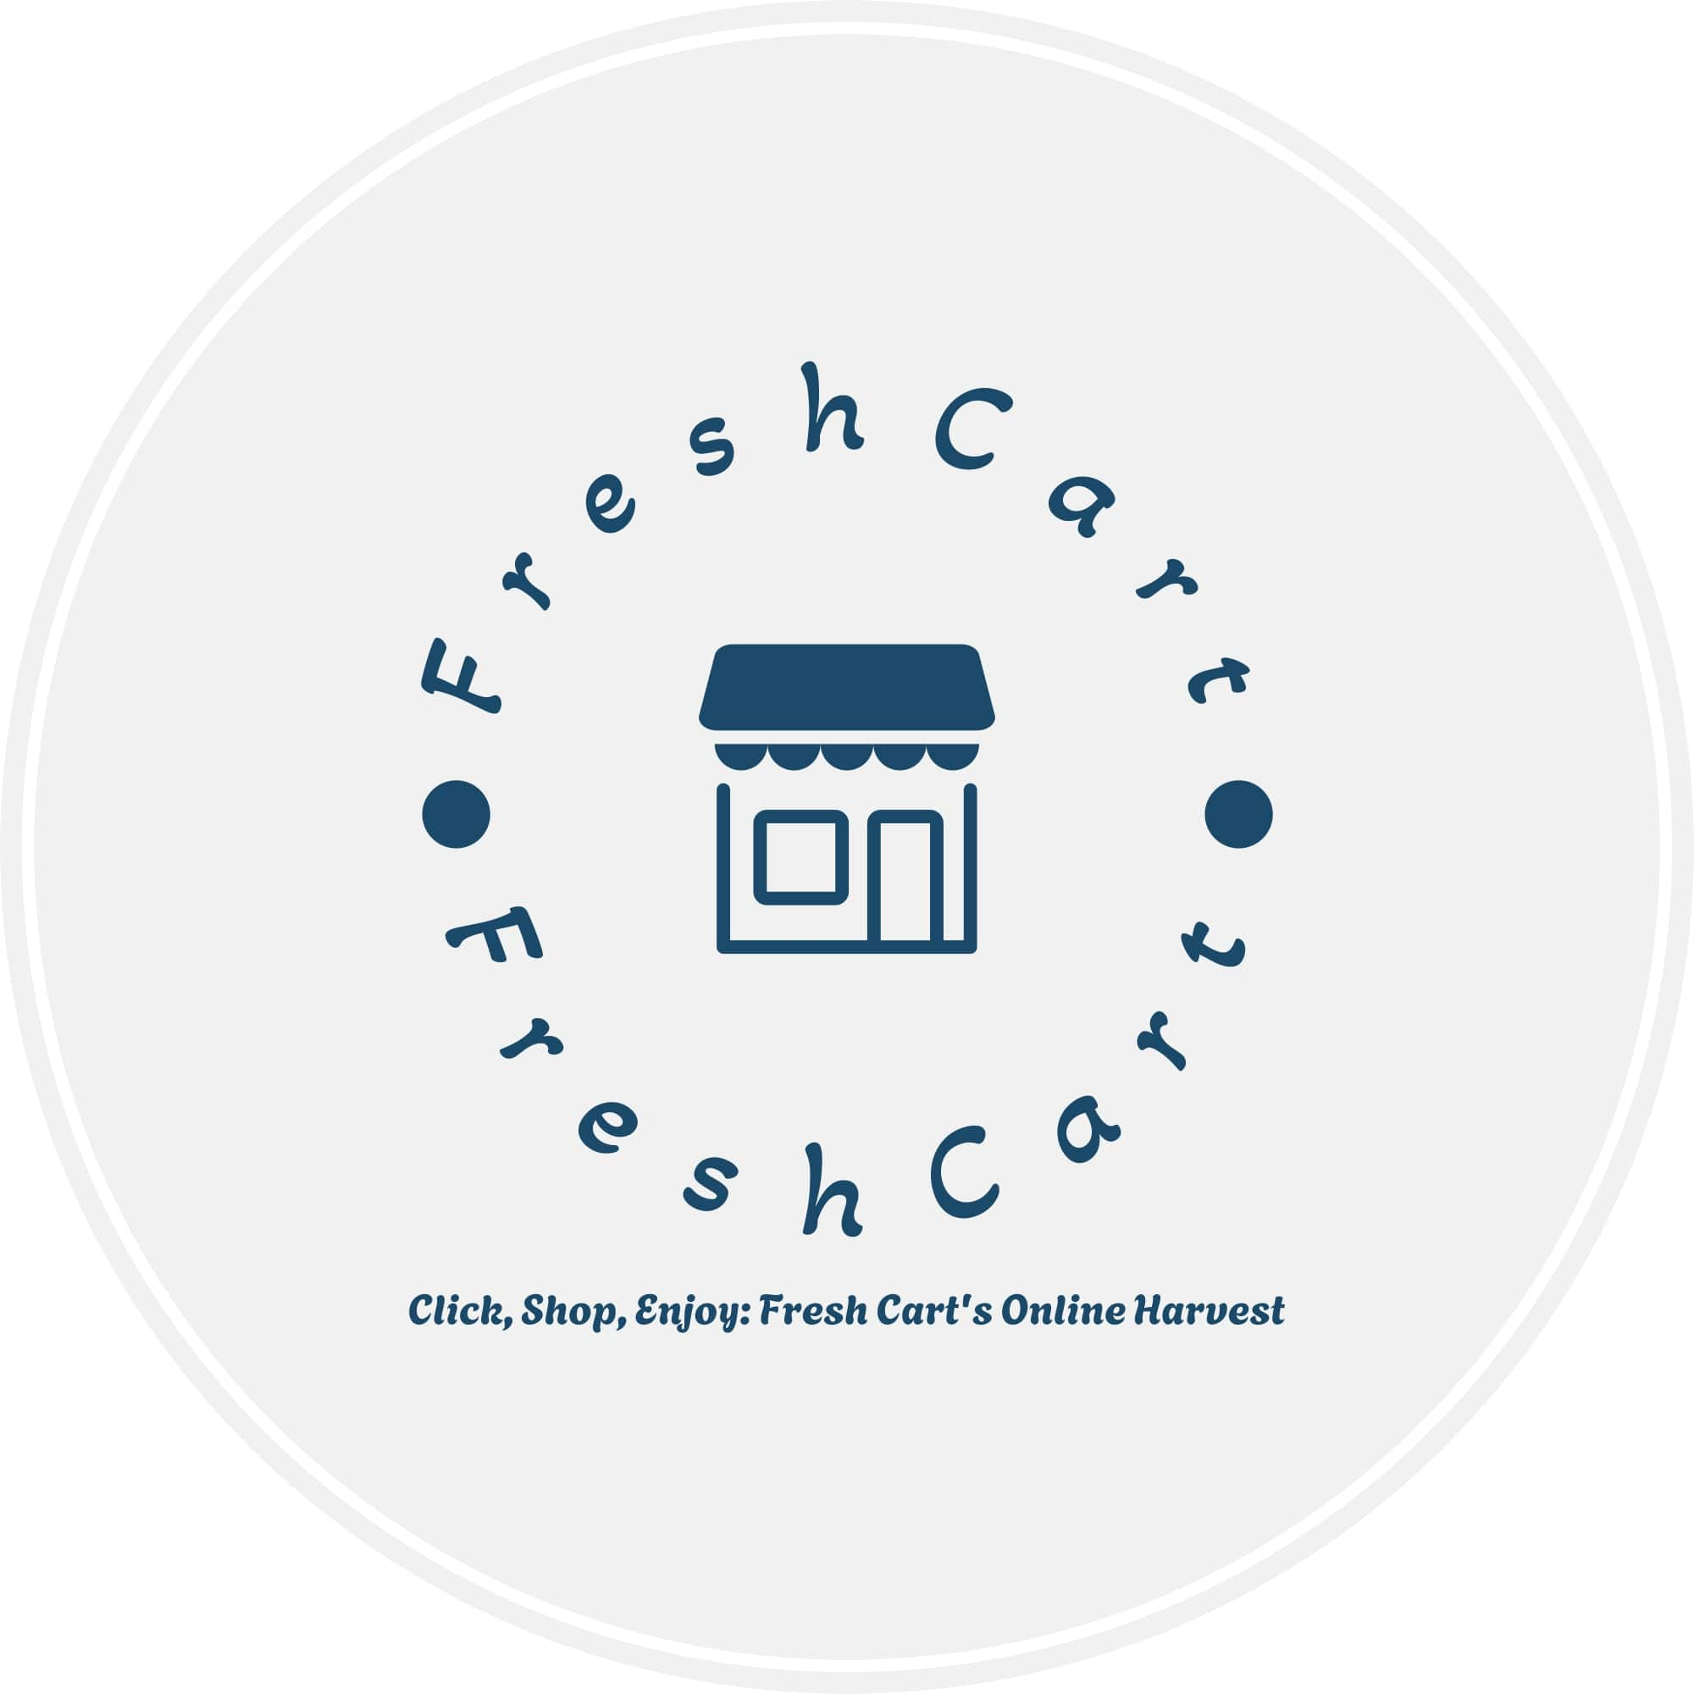

* **DASH BOARD DESIGN**

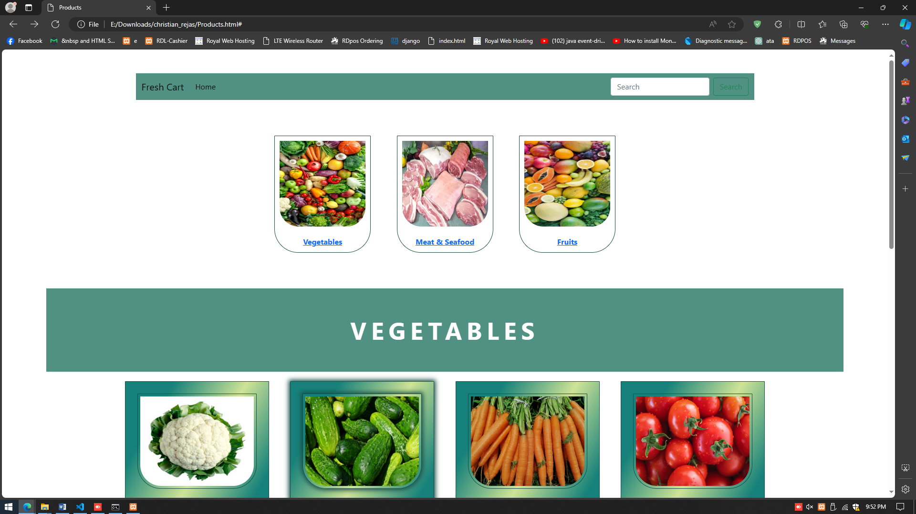

**SCREENSHOTS**

* **LOG-IN AND SIGN UP DESIGN**

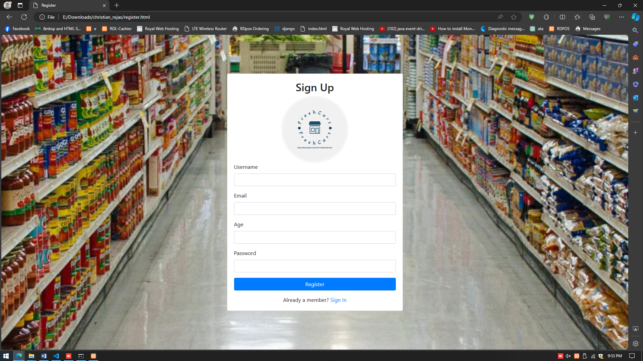

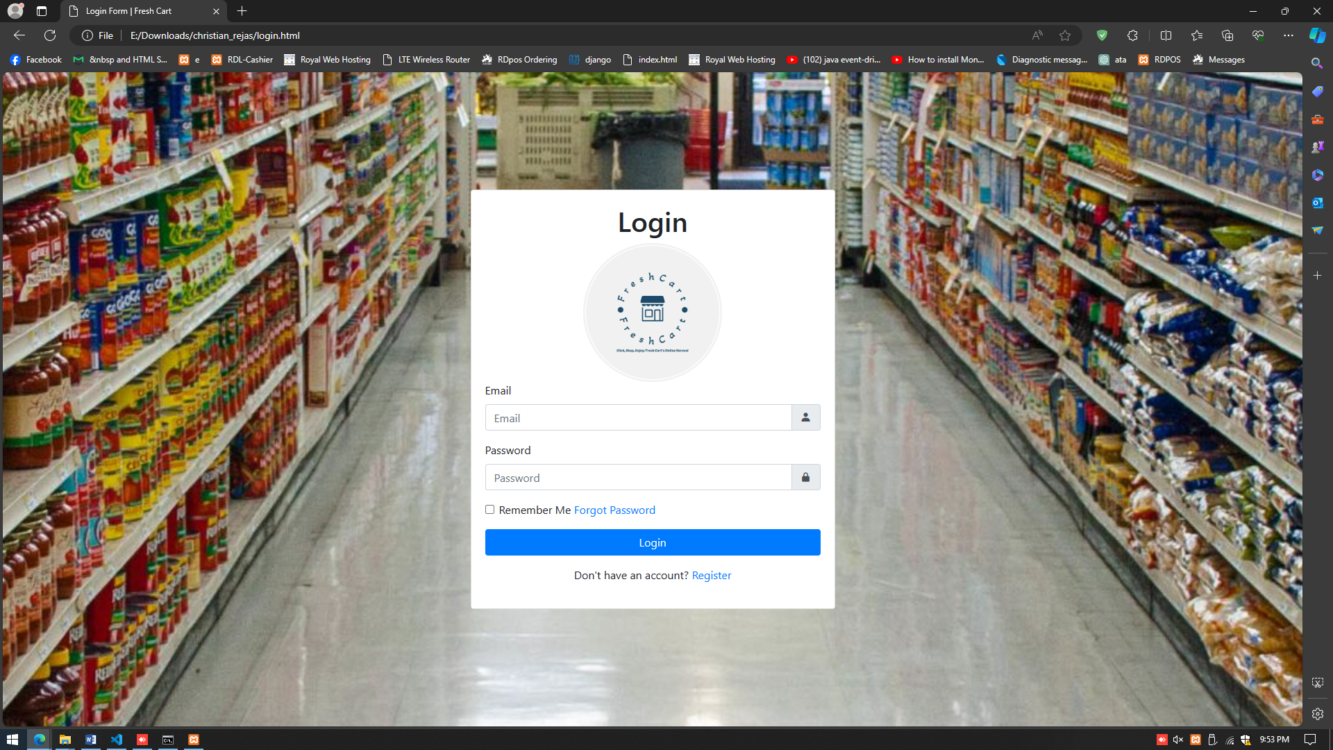

**SCREENSHOTS**

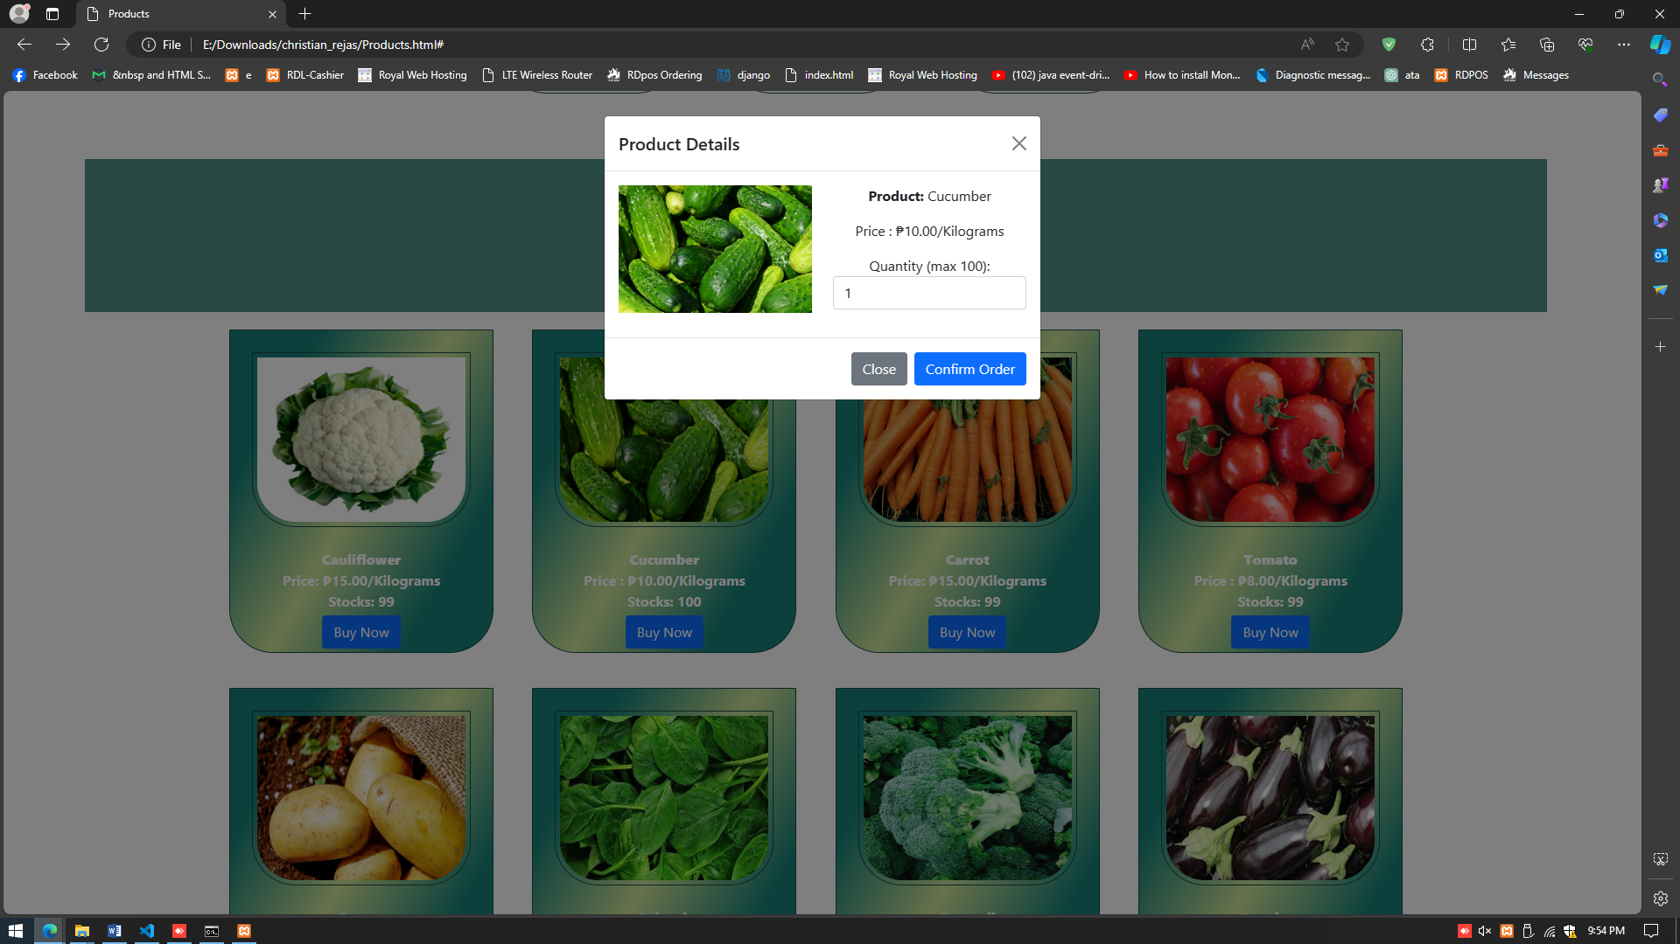

* **CRUD DESIGN**

**D- MAIN TRANSACTION PAGE DESIGN**

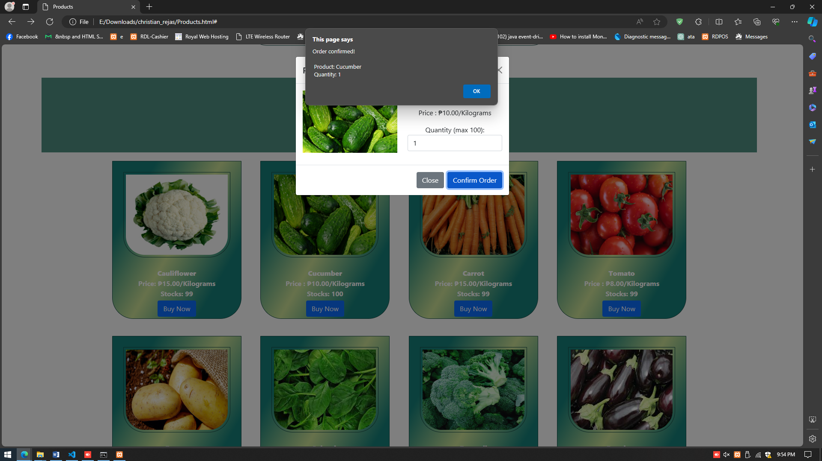

**SCREENSHOTS**

**E - DATABASE DESIGN (XAMPP)**

**(sample)**

**Student Record Table**

|  |  |  |
| --- | --- | --- |
| **Field Names** | **Data Type** | **Length** |
| **PK - StudentID** | **Integer – Auto Increment** | **11** |
| **Last Name** | **Text** | **25** |
| **First Name** | **Text** | **40** |
| **Age** | **Integer** | **2** |
| **Address** | **Text** | **100** |

**Course Table**

|  |  |  |
| --- | --- | --- |
| **Field Names** | **Data Type** | **Length** |
| **PK - CourseID** | **Integer – Auto Increment** | **11** |
| **FK- StudentID** | **Integer** | **11** |
| **Subject Code** | **Text** | **10** |
| **Subject Description** | **Text** | **50** |

**F – ENTITY RELATIONSHIP DIAGRAM**

**SCREENSHOTS**

**G - SOURCE CODE**

**HTML**

**Homepage.html**

<!DOCTYPE html>

<html lang="en">

<head>

<meta name="Author" content="Pyel">

<meta name="Description" content="Fresh Cart - Your Online Grocery Store">

<link rel="stylesheet" href="style/PyelStyle.css"/>

<link rel="stylesheet" href="https://cdnjs.cloudflare.com/ajax/libs/font-awesome/6.5.1/css/all.min.css">

</head>

<body>

<div class="pyel">

<div class="page-title">Fresh Cart</div>

</div>

<div class="menu" id="sticky">

<ul class="menu-ul">

<li><a href="Homepage.html" class="a-menu">Home</a></li>

<li><a href="Products.html" class="a-menu">Products</a></li>

<li><a href="Loginpage.html" class="a-menu">Login/Sign In</a></li>

<li><a href="#" class="a-menu">Cart</a></li>

</ul>

<div class="search-box">

<form>

<input type="text" placeholder="Search..." name="search" class="search-input"/>

<button type="submit"><i class="fas fa-search"></i></button>

</form>

</div>

<button class="admin-btn">Admin</button>

</div>

<div class="flex-container">

<div class="flex-item1">

<div class="content1">

<img src="style/img/FreshCartLOGO.jpg" alt="Fresh Cart Logo">

</div>

</div>

<div class="flex-item1" id="flex-image">

<div class="content2">

<img src="style/img/bg.jpg" alt="Image">

</div>

</div>

</div>

</section>

</body>

</html>

**Loginpage.html**

<!DOCTYPE html>

<html lang="en">

<head>

<meta charset="UTF-8">

<meta name="viewport" content="width=device-width, initial-scale=1.0">

<title>Login Form | Fresh Cart</title>

<link rel="stylesheet" href="style/styles.css">

<link href='https://unpkg.com/boxicons@2.1.4/css/boxicons.min.css' rel='stylesheet'>

</head>

<body>

<div class="wrapper">

<form action="Loginpage.html" method="post">

<h1>Login</h1>

<div class="input-box">

<input type="text" name="email" placeholder="Email" required>

<i class='bx bxs-user'></i>

</div>

<div class="input-box">

<input type="password" name="password" placeholder="Password" required>

<i class='bx bxs-lock-alt'></i>

</div>

<div class="remember-forgot">

<label><input type="checkbox">Remember Me</label>

<a href="#">Forgot Password</a>

</div>

<button type="submit" name="submit" class="btn">Login</button>

<div class="register-link">

<p>Don't have an account? <a href="register.html">Register</a></p>

</div>

</form>

</div>

</body>

</html>

**Products.html**

<!DOCTYPE html>

<html lang="en">

<head>

<meta charset="UTF-8">

<meta name="viewport" content="width=device-width, initial-scale=1.0">

<link rel="stylesheet" href="style/prstyle.css"/>

<title>Products</title>

</head>

<body>

<div class="header">

<h1>PRODUCTS</h1>

<a href="Homepage.html" class="home-btn"><h1>HOME</h1></a>

</div>

<div class="container">

<a href="#Vegetables" class="categories">

<img src="style/img/Vegetables.jpg" class="item-image"/>

<div class="image-title">Vegetables</div>

</a>

<a href="#Meats" class="categories">

<img src="style/img/Chicken Meat.jpg" class="item-image"/>

<div class="image-title">Meat & Seafood</div>

</a>

<a href="#Fruits" class="categories">

<img src="style/img/Fruits.jpg" class="item-image"/>

<div class="image-title">Fruits</div>

</a>

</div>

<!-- Products Ends Here -->

<!-- Veg Begins Here -->

<div class="vegetables-container" id="Vegetables">

<div class="pyelmf">

<div class="title">VEGETABLES</div>

</div>

<div class="items">

<div class="images">

<img src="style/img/Cauliflower.jpg" class="item-image-size"/>

</div>

<div class="description">

<b>Cauliflower</b><br/>

<div class="item-select">

Price: ₱15.00/Kilograms

</div>

<label>Qty:</label>

<select class="item-select">

<option>1 Kilograms</option>

<option>2 Kilograms</option>

<option>3 Kilograms</option>

<option>4 Kilograms</option>

<option>5 Kilograms</option>

<option>6 Kilograms</option>

<option>7 Kilograms</option>

<option>8 Kilograms</option>

<option>9 Kilograms</option>

<option>10 Kilograms</option>

</select><br/>

<button class="buynow-btn">Buy Now</button>

</div>

</div>

<div class="items">

<div class="images">

<img src="style/img/Cucumber.jpg" class="item-image-size"/>

</div>

<div class="description">

<b>Cucumber</b><br/>

<div class="item-select">

Price : ₱10.00/Kilograms

</div>

<label>Qty:</label>

<select class="item-select">

<option>1 Kilograms</option>

<option>2 Kilograms</option>

<option>3 Kilograms</option>

<option>4 Kilograms</option>

<option>5 Kilograms</option>

<option>6 Kilograms</option>

<option>7 Kilograms</option>

<option>8 Kilograms</option>

<option>9 Kilograms</option>

<option>10 Kilograms</option>

</select><br/>

<button class="buynow-btn">Buy Now</button>

</div>

</div>

<div class="items">

<div class="images">

<img src="style/img/Carrot.jpg" class="item-image-size"/>

</div>

<div class="description">

<b>Carrot</b><br/>

<div class="item-select">

Price: ₱15.00/Kilograms

</div>

<label>Qty:</label>

<select class="item-select">

<option>1 Kilograms</option>

<option>2 Kilograms</option>

<option>3 Kilograms</option>

<option>4 Kilograms</option>

<option>5 Kilograms</option>

<option>6 Kilograms</option>

<option>7 Kilograms</option>

<option>8 Kilograms</option>

<option>9 Kilograms</option>

<option>10 Kilograms</option>

</select><br/>

<button class="buynow-btn">Buy Now</button>

</div>

</div>

<div class="items">

<div class="images">

<img src="style/img/Tomatoes.jpg" class="item-image-size"/>

</div>

<div class="description">

<b>Tomato</b><br/>

<div class="item-select">

Price : ₱8.00/Kilograms

</div>

<label>Qty:</label>

<select class="item-select">

<option>1 Kilograms</option>

<option>2 Kilograms</option>

<option>3 Kilograms</option>

<option>4 Kilograms</option>

<option>5 Kilograms</option>

<option>6 Kilograms</option>

<option>7 Kilograms</option>

<option>8 Kilograms</option>

<option>9 Kilograms</option>

<option>10 Kilograms</option>

</select><br/>

<button class="buynow-btn">Buy Now</button>

</div>

</div>

<div class="items">

<div class="images">

<img src="style/img/Potatoes.jpg" class="item-image-size"/>

</div>

<div class="description">

<b>Potato</b><br/>

<div class="item-select">

Price : ₱12.00/Kilograms

</div>

<label>Qty:</label>

<select class="item-select">

<option>1 Kilograms</option>

<option>2 Kilograms</option>

<option>3 Kilograms</option>

<option>4 Kilograms</option>

<option>5 Kilograms</option>

<option>6 Kilograms</option>

<option>7 Kilograms</option>

<option>8 Kilograms</option>

<option>9 Kilograms</option>

<option>10 Kilograms</option>

</select><br/>

<button class="buynow-btn">Buy Now</button>

</div>

</div>

<div class="items">

<div class="images">

<img src="style/img/spinach.jpg" class="item-image-size"/>

</div>

<div class="description">

<b>Spinach</b><br/>

<div class="item-select">

Price: ₱7.00/Kilograms

</div>

<label>Qty:</label>

<select class="item-select">

<option>1 Kilograms</option>

<option>2 Kilograms</option>

<option>3 Kilograms</option>

<option>4 Kilograms</option>

<option>5 Kilograms</option>

<option>6 Kilograms</option>

<option>7 Kilograms</option>

<option>8 Kilograms</option>

<option>9 Kilograms</option>

<option>10 Kilograms</option>

</select><br/>

<button class="buynow-btn">Buy Now</button>

</div>

</div>

<div class="items">

<div class="images">

<img src="style/img/Broccoli.jpg" class="item-image-size"/>

</div>

<div class="description">

<b>Broccoli</b><br/>

<div class="item-select">

Price: ₱10.00/Kilograms

</div>

<label>Qty:</label>

<select class="item-select">

<option>1 Kilograms</option>

<option>2 Kilograms</option>

<option>3 Kilograms</option>

<option>4 Kilograms</option>

<option>5 Kilograms</option>

<option>6 Kilograms</option>

<option>7 Kilograms</option>

<option>8 Kilograms</option>

<option>9 Kilograms</option>

<option>10 Kilograms</option>

</select><br/>

<button class="buynow-btn">Buy Now</button>

</div>

</div>

<div class="items">

<div class="images">

<img src="style/img/Eggplant.jpg" class="item-image-size"/>

</div>

<div class="description">

<b>Eggplant</b><br/>

<div class="item-select">

Price: ₱10.00/Kilograms

</div>

<label>Qty:</label>

<select class="item-select">

<option>1 Kilograms</option>

<option>2 Kilograms</option>

<option>3 Kilograms</option>

<option>4 Kilograms</option>

<option>5 Kilograms</option>

<option>6 Kilograms</option>

<option>7 Kilograms</option>

<option>8 Kilograms</option>

<option>9 Kilograms</option>

<option>10 Kilograms</option>

</select><br/>

<button class="buynow-btn">Buy Now</button>

</div>

</div>

<div class="meat-seafood-container" id="Meats">

<div class="pyelmf">

<div class="title">MEAT & SEAFOOD</div>

</div>

<div class="items">

<div class="images">

<img src="style/img/Chicken meat.jpg" class="item-image-size"/>

</div>

<div class="description">

<b>Chicken</b><br/>

<div class="item-select">

Price: ₱120.00/Kilograms

</div>

<label>Qty:</label>

<select class="item-select">

<option>1 Kilograms</option>

<option>1.5 Kilograms</option>

<option>2 Kilograms</option>

<option>2.5 Kilograms</option>

<option>3 Kilograms</option>

<option>3.5 Kilograms</option>

<option>4 Kilograms</option>

<option>4.5 Kilograms</option>

<option>5 Kilograms</option>

</select><br/>

<button class="buynow-btn">Buy Now</button>

</div>

</div>

<div class="items">

<div class="images">

<img src="style/img/Shrimp.jpg" class="item-image-size"/>

</div>

<div class="description">

<b>Shrimp</b><br/>

<div class="item-select">

Price: ₱250.00/Kilograms

</div>

<label>Qty:</label>

<select class="item-select">

<option>0.5 Kilograms</option>

<option>1 Kilograms</option>

<option>1.5 Kilograms</option>

<option>2 Kilograms</option>

<option>2.5 Kilograms</option>

<option>3 Kilograms</option>

<option>3.5 Kilograms</option>

<option>4 Kilograms</option>

<option>4.5 Kilograms</option>

<option>5 Kilograms</option>

</select><br/>

<button class="buynow-btn">Buy Now</button>

</div>

</div>

</div>

</body>

</html>

**register.html**

<!DOCTYPE html>

<html lang="en">

<head>

<meta charset="UTF-8">

<meta http-equiv="X-UA-Compatible" content="IE=edge">

<meta name="viewport" content="width=device-width, initial-scale=1.0">

<link rel="stylesheet" href="style/style.css">

<title>Register</title>

</head>

<body>

<div class="container">

<div class="box form-box">

<header>Sign Up</header>

<form action="" method="post">

<div class="field input">

<label for="username">Username</label>

<input type="text" name="username" id="username" autocomplete="off" required>

</div>

<div class="field input">

<label for="email">Email</label>

<input type="text" name="email" id="email" autocomplete="off" required>

</div>

<div class="field input">

<label for="age">Age</label>

<input type="number" name="age" id="age" autocomplete="off" required>

</div>

<div class="field input">

<label for="password">Password</label>

<input type="password" name="password" id="password" autocomplete="off" required>

</div>

<div class="field">

<input type="submit" class="btn" name="submit" value="Register" required>

</div>

<div class="links">

Already a member? <a href="Loginpage.html">Sign In</a>

</div>

</form>

</div>

<?php } ?>

</div>

</body>

</html>

**CSS**

**prstyle.css**

.container, .vegetables-container{

margin:50px 50px 50px 5%;

width:90%;

text-align:center;

}

.header {

background:rgba(2, 95, 75, 0.685);

padding: 10px;

color:white;

text-align: center;

}

.categories, .items{

width:max-content;

margin:25px;

border:1px solid #184d47;

border-radius:0 0 50px 50px;

display:inline-block;

}

.categories:hover, .items:hover{

box-shadow:0 0 10px 3px #184d47;

}

.item-image{

height:200px;

width:200px;

border-radius:0 0 50px 50px;

padding:10px;

}

.image-title{

text-align:center;

padding:10px;

font-weight:bold;

}

a{

text-decoration:none;

}

.title{

padding:50px;

font-size:50px;

font-weight:bold;

letter-spacing:10px;

color:white;

background:rgba(2, 95, 75, 0.685);

}

.items{

padding:50;

font-size:20;

font-weight:bold;

color:white;

display:inline-block;

margin:20px;

max-width:20%;

background:linear-gradient(120deg, #16817a 20%, #cee397 50%, #16817a 80%);

}

.images{

display:inline-block;

}

.item-image-size{

height:200px;

margin:25px;;

width:250px;

padding:5px;

border: 1px solid #184d47;

border-radius: 0 0 50px 50px;

display: inline-block;

}

.item-image-size:hover {

box-shadow: 0 0 10px 3px #184d47;

}

**Pyelstyle.css**

body {

margin: 0;

font-family: system-ui;

}

.pyel {

background-image: url('img/bg.jpg');

height: max-content;

background-attachment: fixed;

background-position: center;

background-repeat: no-repeat;

background-size: cover;

}

.page-title {

background: rgba(0,0,0,0.5);

text-align: center;

color: white;

padding: 50px;

font-variant: small-caps;

font-size: 100px;

font-family: fantasy;

letter-spacing: 20px;

}

.menu{

background: #1777d1c9;

text-align: center;

}

.menu-ul{

margin: 0;

padding: 0;

display: inline;

}

.menu-ul li{

font-size: 17px;

list-style: none;

display: inline-block;

padding: 25px 25px 26px 25px;

}

.a-menu{

text-decoration: none;

color: rgb(36, 236, 169);

}

.menu-ul li:hover{

background: #0fe7e7;

transform: scale(1.1);

}

.search-box{

border: 1px solid rgb(255, 255, 255);

border-radius: 50px;

background: white;

display: inline-block;

margin: 15px 0 0 10px;

}

.search-box:hover{

box-shadow: 0 0 10px 2px #03bae7;

border: 1px solid #0fe7e7;

}

.search-input{

width: 250px;

border: none;

font-size: 16px;

outline: none;

background: transparent;

margin: 15px 0 0 10px;

}

i{

font-size: 30px;

margin: 0 10px 0 0;

}

button{

background: transparent;

border: none;

outline: none;

}

.admin-btn {

background-color: #1777d1c9;

color: white;

font-size: 17px;

padding: 15px 25px;

margin-right: 10px; /* Adjust margin as needed */

border: none;

border-radius: 20px;

cursor: pointer;

}

.admin-btn:hover {

background-color: #0fe7e7;

}

.flex-container {

display:flex;

display:-webkit-flex;

display:-moz-flex;

width:100%;

height:100%;

}

.flex-item1 {

width:80%;

height:450px;

position:relative;

}

.content1 {

width: 50%;

height: 100%;

position: absolute;

top: 50%;

left: 50%;

transform: translate(-50%, -50%);

}

.content1 img {

width: 100%;

height: auto;

object-fit: contain;

}

.content2 {

margin:0 0 10px;

padding:0;

height: 100%;

}

.content2 img {

width:100%;

height:100%;

object-fit: cover;

}

**stlye.css**

*{

padding: 0;

margin: 0;

box-sizing: border-box;

font-family: 'Poppins',sans-serif;

}

body{

background: #e4e9f7;

}

.container{

display: flex;

align-items: center;

justify-content: center;

min-height: 90vh;

}

.box{

background: #fdfdfd;

display: flex;

flex-direction: column;

padding: 25px 25px;

border-radius: 20px;

box-shadow: 0 0 128px 0 rgba(0,0,0,0.1),

0 32px 64px -48px rgba(0,0,0,0.5);

}

.form-box{

width: 450px;

margin: 0px 10px;

}

.form-box header{

font-size: 25px;

font-weight: 600;

padding-bottom: 10px;

border-bottom: 1px solid #e6e6e6;

margin-bottom: 10px;

}

.form-box form .field{

display: flex;

margin-bottom: 10px;

flex-direction: column;

}

.form-box form .input input{

height: 40px;

width: 100%;

font-size: 16px;

padding: 0 10px;

border-radius: 5px;

border: 1px solid #ccc;

outline: none;

}

.btn{

height: 35px;

background: rgba(76,68,182,0.808);

border: 0;

border-radius: 5px;

color: #fff;

font-size: 15px;

cursor: pointer;

transition: all .3s;

margin-top: 10px;

padding: 0px 10px;

}

.btn:hover{

opacity: 0.82;

}

.links{

margin-bottom: 15px;

}

.message{

text-align: center;

background: #f9eded;

padding: 15px 0px;

border:1px solid #699053;

border-radius: 5px;

margin-bottom: 10px;

color: red;

}

**styles.css**

*{

margin: 0;

padding: 0;

box-sizing: border-box;

font-family: "Poppins", sans-serif;

}

body{

display: flex;

justify-content: center;

align-items: center;

min-height: 100vh;

background: url('img/Background1.jpg') no-repeat;

background-size: cover;

background-position: center;

}

.wrapper{

width: 420px;

background: transparent;

border: 2px solid rgba(255, 255, 255, .2);

color: #fff;

border-radius: 12px;

padding: 30px 40px;

}

.wrapper h1{

font-size: 36px;

text-align: center;

}

.wrapper .input-box{

position: relative;

width: 100%;

height: 50px;

margin: 30px 0;

}

.input-box input{

width: 100%;

height: 100%;

background: transparent;

border: none;

outline: none;

border: 2px solid rgba(255, 255, 255, .2);

border-radius: 40px;

font-size: 16px;

color: #fff;

padding: 20px 45px 20px 20px;

}

.input-box input::placeholder{

color: #fff;

}

.input-box i{

position: absolute;

right: 20px;

top: 30%;

transform: translate(-50%);

font-size: 20px;

}

.wrapper .remember-forgot{

display: flex;

justify-content: space-between;

font-size: 14.5px;

margin: -15px 0 15px;

}

.remember-forgot label input{

accent-color: #fff;

margin-right: 3px;

}

.remember-forgot a{

color: #fff;

text-decoration: none;

}

.remember-forgot a:hover{

text-decoration: underline;

}

.wrapper .btn{

width: 100%;

height: 45px;

background: #fff;

border: none;

outline: none;

border-radius: 40px;

box-shadow: 0 0 10px rgba(0, 0, 0, .1);

cursor: pointer;

font-size: 16px;

color: #333;

font-weight: 600;

}

.wrapper .register-link{

font-size: 14.5px;

text-align: center;

margin: 20px 0 15px;

}

.register-link p a{

color: #fff;

text-decoration: none;

font-weight: 600;

}

.register-link p a:hover{

text-decoration: underline;

}